**NAME: AJINKYA ANAND THAKUR**

**ROLL NO: 2401199**

**Practical Assignments: Node.js**

1. Create a function to Print prime numbers in an interval of 10 to 50.

-> function printPrimes(start, end) {

    for (let num = start; num <= end; num++) {

        let isPrime = true;

        if (num < 2) continue;

        for (let i = 2; i <= Math.sqrt(num); i++) {

            if (num % i === 0) {

                isPrime = false;

                break;

            }

        }

        if (isPrime) console.log(num);

    }

}

printPrimes(10, 50);

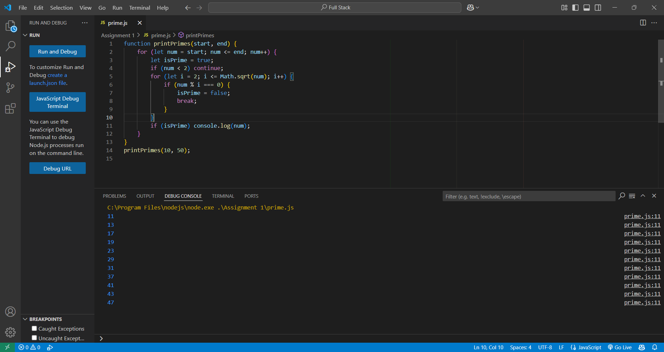

1. Create a function to Check if a number is Armstrong number

-> function isArmstrong(num) {

    const digits = num.toString().split('');

    const sum = digits.reduce((acc, digit) => acc + Math.pow(Number(digit), digits.length), 0);

    return sum === num;

}

console.log(isArmstrong(153));

1. Create a function to Check if a number is Perfect number

-> function isPerfect(num) {

    let sum = 0;

    for (let i = 1; i <= num / 2; i++) {

        if (num % i === 0) sum += i;

    }

    return sum === num;

}

console.log(isPerfect(28));

1. Create a function to Count occurrence of character in a string

-> function countCharacter(str, char) {

    return str.split(char).length - 1;

}

console.log(countCharacter("hello world", "o"));

1. Create a function to Create array, sort array, concatenate two arrays.

-> function arrayOperations() {

const arr1 = [5, 2, 9, 1];

const arr2 = [10, 4, 6];

console.log(arr1.sort((a, b) => a - b));

console.log(arr1.concat(arr2));

}

arrayOperations();

1. Create a function to Create array, get the sum of all elements in an array, remove specific element from array.

-> function arrayOperations() {

const arr = [1, 2, 3, 4, 5];

const sum = arr.reduce((a, b) => a + b, 0);

const removeElement = (arr, element) => arr.filter(item => item !== element);

console.log("Sum:", sum);

console.log("After Removal:", removeElement(arr, 3));

}

arrayOperations();

1. Create a function to Implement stack operations.

-> class Stack {

constructor() {

this.stack = [];

}

push(item) { this.stack.push(item); }

pop() { return this.stack.pop(); }

peek() { return this.stack[this.stack.length - 1]; }

isEmpty() { return this.stack.length === 0; }

}

const stack = new Stack();

stack.push(10);

stack.push(20);

console.log(stack.pop());

1. Create a function to Print Multiplication table.

-> function printTable(num) {

    for (let i = 1; i <= 10; i++) {

        console.log(`${num} x ${i} = ${num * i}`);

    }

}

printTable(11);

1. Create a function to Convert decimal number to binary.

-> function decimalToBinary(num) {

    return num.toString(2);

}

console.log(decimalToBinary(99));

1. Create a function which will display a message “welcome to node js” 10 times with a delay of 2 seconds between iterations (use setTimeout).

->function displayMessage() {

    for (let i = 1; i <= 10; i++) {

        setTimeout(() => console.log("Welcome to Node.js"), i * 2000);

    }

}

displayMessage();

1. Create a Node JS Script file that displays hostname, platform, home directory, total memory, free memory details of current system on the console.

-> const os = require('os');

console.log("Hostname:", os.hostname());

console.log("Platform:", os.platform());

console.log("Home Directory:", os.homedir());

console.log("Total Memory:", os.totalmem());

console.log("Free Memory:", os.freemem());

1. Create a Node JS script file that displays Hello text in red color, underline and “Welcome to Node JS” text in rainbow colors on the console.

-> import chalk from 'chalk';

import chalkAnimation from 'chalk-animation';

console.log(chalk.red('Hello'));

const rainbow = chalkAnimation.rainbow('Welcome to Node JS');

setTimeout(() => {

    rainbow.stop();

}, 3000);

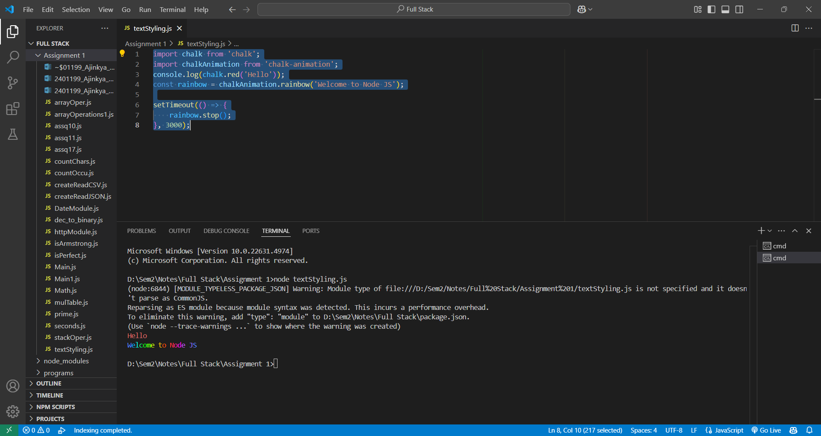

1. Create a user defined module named Math with four functions Addition, Subtraction, Multiplication, Division and export them. Import Math module form other Node JS Script file and invoke all the four functions to perform operations on given input.

->Math.js

module.exports = {

add: (a, b) => a + b,

subtract: (a, b) => a - b,

multiply: (a, b) => a * b,

divide: (a, b) => a / b,

};

Main.js

const Math = require('./Math');

console.log(Math.add(5, 3));

console.log(Math.subtract(5, 3));

1. Write a node script file to display current date time by using user defined date module.

->DateModule.js

module.exports.getCurrentDateTime = () => new Date();

Main1.js

const dateModule = require('./DateModule');

console.log(dateModule.getCurrentDateTime());

1. Write a Node script file to find out how many seconds are there in a year. How many seconds are there in a century and writes the result into a file.

-> const fs = require('fs');

const secondsInYear = 365 * 24 * 60 * 60;

const secondsInCentury = 100 * secondsInYear;

fs.writeFileSync('seconds.txt', `Year: ${secondsInYear}, Century: ${secondsInCentury}`);

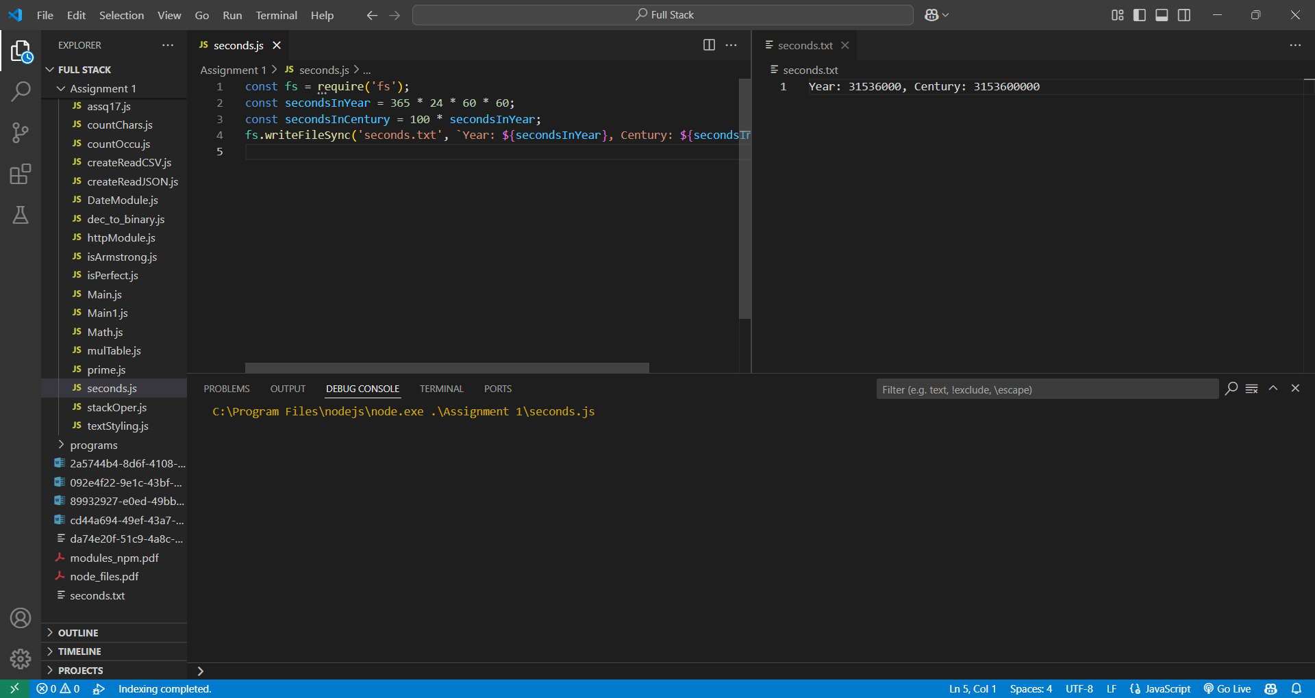

1. Write a program to create http module to transfer data over the HTTP protocol.

-> const http = require('http');

http.createServer((req, res) => {

res.write("Hello, HTTP!");

res.end();

}).listen(8080);

1. Write a program to count lines, words and characters in a text file.

-> const fs = require('fs');

const content = fs.readFileSync('file.txt', 'utf-8');

console.log("Lines:", content.split('\n').length);

console.log("Words:", content.split(/\s+/).length);

console.log("Characters:", content.length);

1. Write a program to count characters, digits, vowels, consonants and special characters in a text file.

-> const fs = require('fs');

const content = fs.readFileSync('file.txt', 'utf-8');

console.log("Characters:", content.length);

console.log("Digits:", (content.match(/\d/g) || []).length);

console.log("Vowels:", (content.match(/[aeiou]/gi) || []).length);

console.log("Consonants:", (content.match(/[^aeiou\s\d\W]/gi) || []).length);

console.log("Special Characters:", (content.match(/\W/g) || []).length);

1. Write a program to create a csv file, also read and display contents of the csv file (Data: Student name, Age, Weight).

-> const fs = require('fs');

const data = "Name,Age,Weight\nJohn,25,70\nJane,22,65";

fs.writeFileSync('data.csv', data);

console.log(fs.readFileSync('data.csv', 'utf-8'));

1. Write a program to create a json file, also read and display contents of the json file (Data: Employee name, Email, Job Profile).

-> const fs = require('fs');

const data = [{ name: "John", email: "john@example.com", job: "Engineer" }];

fs.writeFileSync('data.json', JSON.stringify(data, null, 2));

console.log(JSON.parse(fs.readFileSync('data.json')));

